SETTING UP ENVIRONMENT CREATE IBM CLOUD ACCOUNT

|  |  |
| --- | --- |
| Team ID | PNT2022TMID17805 |
| Project Name | Customer Care Registry |
| Team Members | Abishek L, Athista Laskhmi  Bala Murguan G, Harshini |

**Step 1:** Start the IBM account creation by visiting [www.ibm.com/academic/home](http://www.ibm.com/academic/home), to begin with registration.

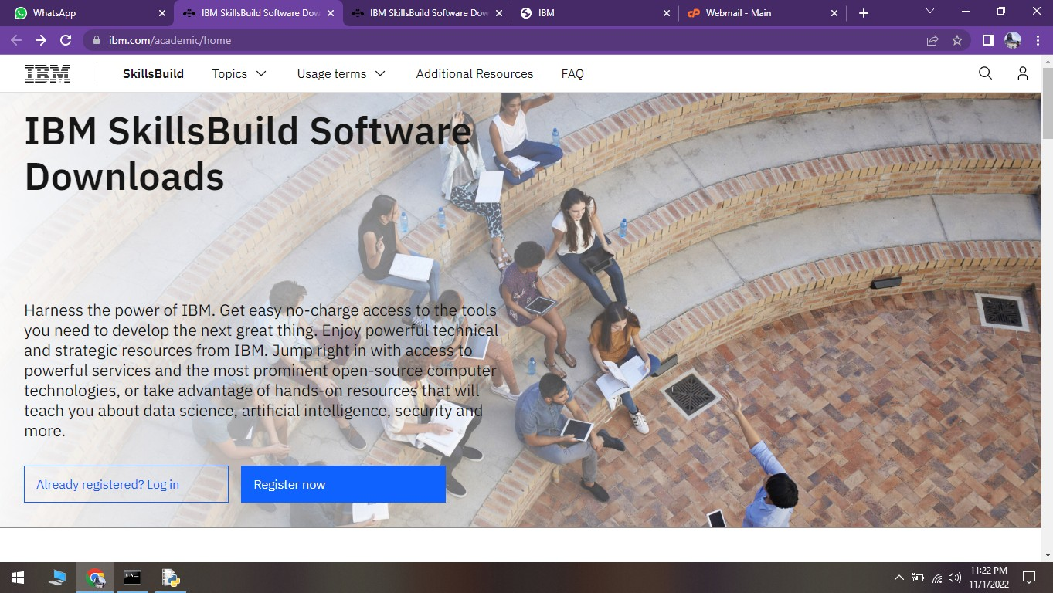

**Step 2:** Use the webmail credentials to register with the IBM cloud and fill in all the other details.

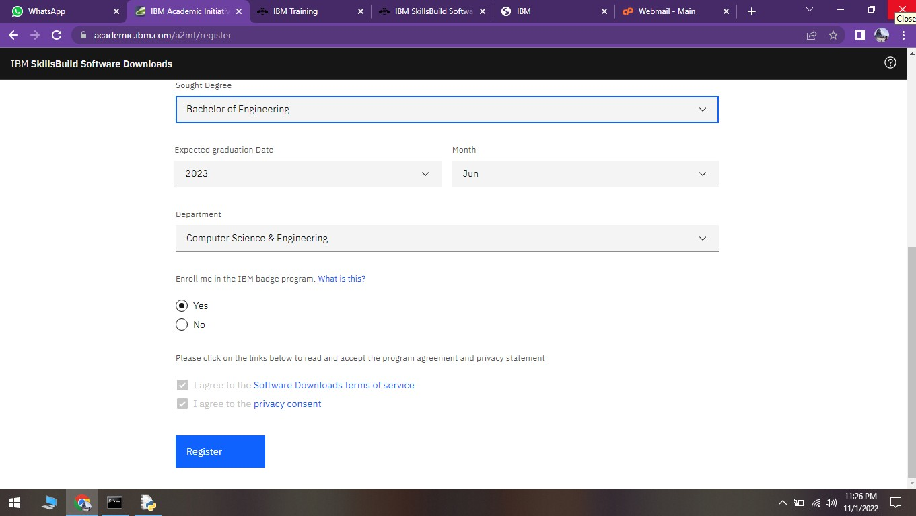

**Step 3:** Log in to the webmail with the given credentials in the profile, and complete the IBM Cloud registration by confirming the OTP.

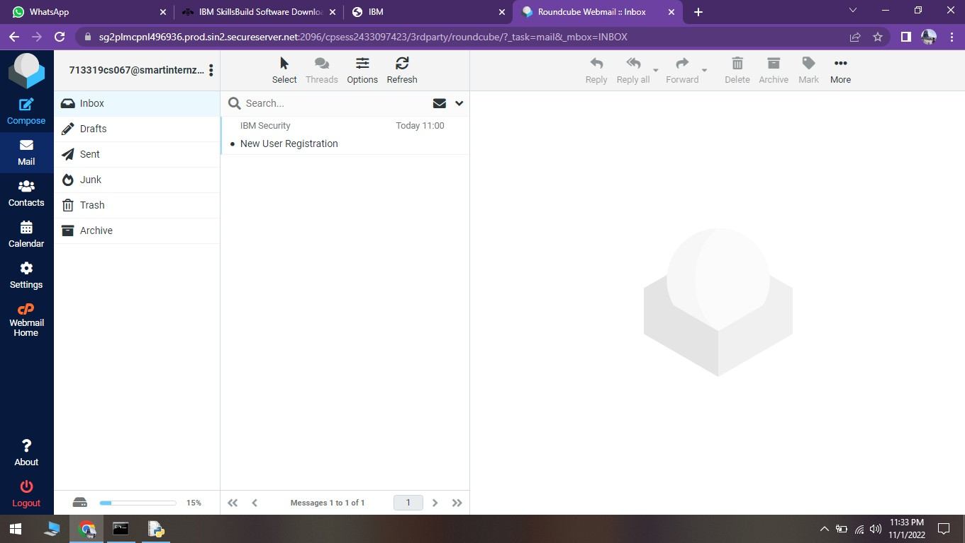

**Step 4:**Now after verifying IBM cloud account is created.

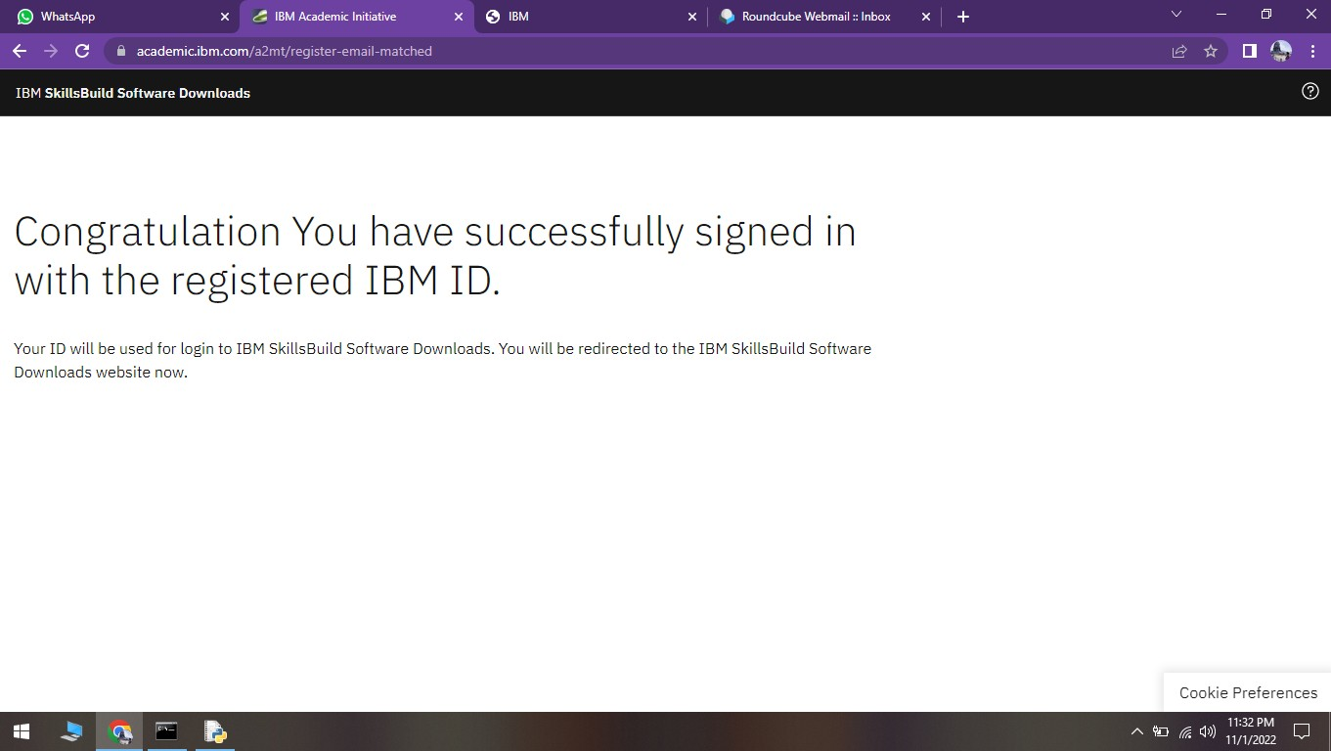

**Step 5:**As the account is created and verified now go to <https://cloud.ibm.com/login>and try logging in.

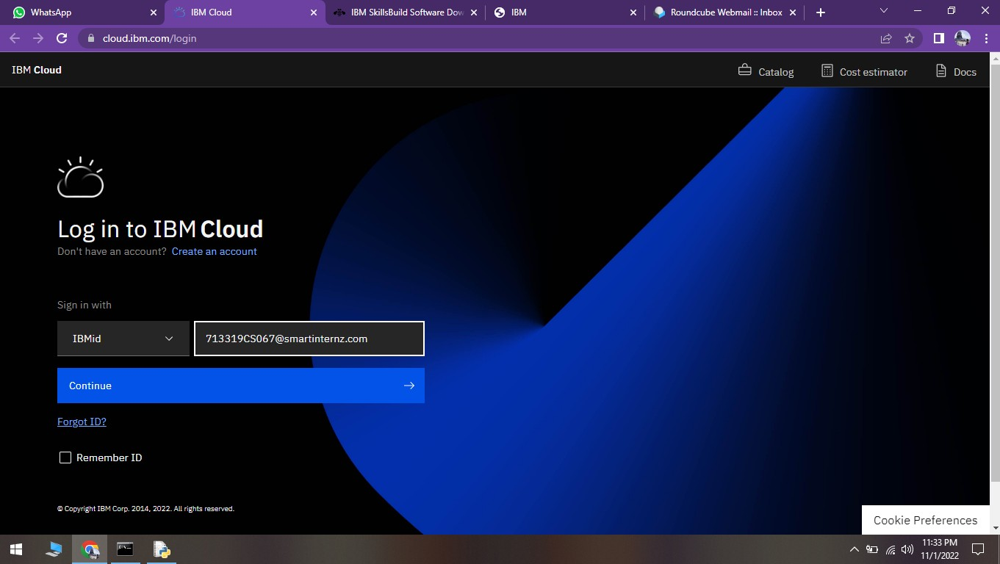

**Step 5:**IBM account is successfully created

